Six Sigma
Six sigma at many organizations simply means striving for near perfection. To achieve six sigma, a process must not produce more than the acceptable defects
The fundamental object of six sigma methodology is the implementation of a measurement-based strategy that focuses on process improvement and variation reduction through the application of six sigma improvement projects.

What is Sigma?
Sigma Level Defects Per Million Rate of
Opportunities Improvement

1 σ 690,000
2 σ 308,000 2 times
3 σ 66,800 5 times
4 σ 6,210 11 times
5 σ 230 27 times
6 σ 3.4 68 times

It has three core steps:
- Define customer requirements, deliverables, and project goals via well-defined methods of customer communication.
- Measure the existing process and its output to determine current quality performance (collect defect metrics)
- Analyze defect metrics and determine the vital few causes
It also suggests additional steps for improvement:
- Improve the process by eliminating the root cause of defects
- Control the process to ensure that future work does not reintroduce the causes of defects

Six Sigma Project Methodology
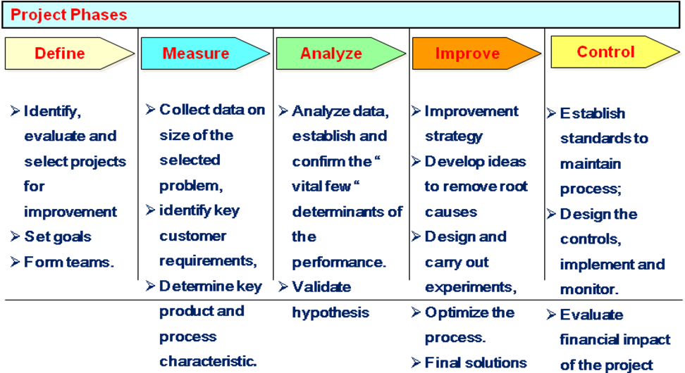

Applying Six Sigma to software development makes product development and other projects transparent to both management and customers. Transparency requires an important cultural change. As a result, after transparency is achieved, completing accurate project estimations while meeting both deadlines and customer requirements becomes a lot easier.
There is no SW metrics that serves all. It depends what kind of software we are developing or installing. Finding good metrics for software development or deployment is a major task in itself.
Software development must adapt to the ever changing human ideas, beliefs, fears, and the corresponding environment. We cannot restrict ourselves to software engineering, we need focus on project management to improve both software development and deployment.
And we need measurements in order to know that we implemented the targets we had planned for.

Principle No 1
􀂷 Measure customer related metrics only
o Use Combinatory Metrics to cover all topics
Principle No 2
􀂷 Adjust to moving targets
o Your goals may need change; accept change and manage it accordingly
Principle No 3
􀂷 Enforce measurement
o Do not enforce meeting targets

What Makes Six Sigma Different?
- Versatile
- Breakthrough improvements
- Financial results focus
- Process focus
- Structured & disciplined problem solving methodology using scientific tools and techniques
- Customer centered
- Involvement of leadership is mandatory.
- Training is mandatory;
- Action learning (25% class room, 75 % application)
- Creating a dedicated organisation for problem solving (85/50 Rule).

Benefits of Six Sigma
- Generates sustained success
- Sets performance goal for everyone
- Enhances value for customers;
- Accelerates rate of improvement;
- Promotes learning across boundaries;
- Executes strategic change

Software Audit
Software audit is a systematic and independent examination to determine the following:
Are quality related arrangements implemented as planned?
Are results consistent with expectations
Adequacy Audit determines the extent to which documented QMS conforms to applicable standards
Compliance Audit is aimed at determining the extent to which the implemented system conforms to documented systems
Surveillance Audit ensures continued adherence to standards and continuous improvement

First party audits:
Performed in-house
QMS requirement
Ensures effective implementation
Evaluate any particular quality problem
Second party audits
Performed by clients
Vendor selection
Third party audits
Certification
Surveys

Documentation standards
Particularly important - documents are the tangible manifestation of the software.
Documentation process standards
Concerned with how documents should be developed, validated and maintained.
Document standards
Concerned with document contents, structure, and appearance.
Document interchange standards
Concerned with the compatibility of electronic documents.

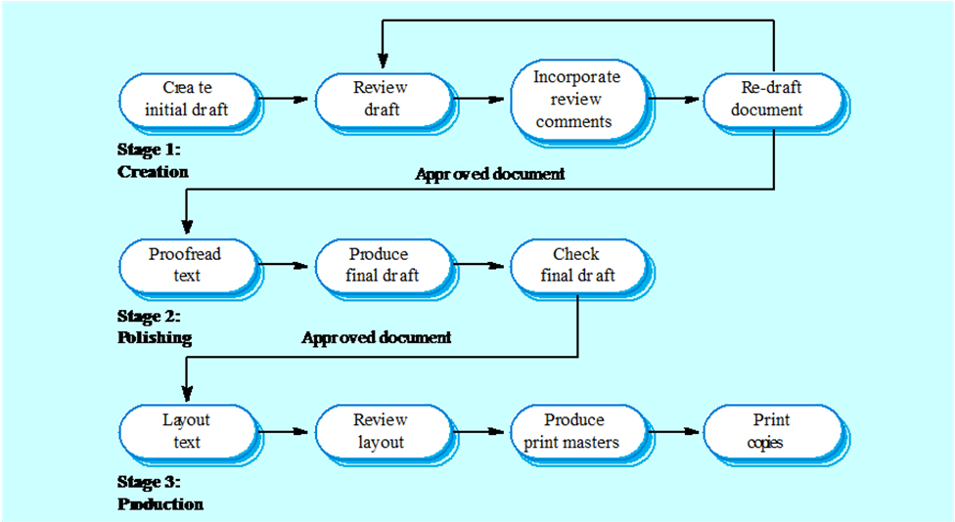

- Document identification standards
  - How documents are uniquely identified.
- Document structure standards
  - Standard structure for project documents.
- Document presentation standards
  - Define fonts and styles, use of logos, etc.
- Document update standards
  - Define how changes from previous versions are reflected in a document.

- Interchange standards allow electronic documents to be exchanged, mailed, etc.
- Documents are produced using different systems and on different computers. Even when standard tools are used, standards are needed to define conventions for their use e.g. use of style sheets and macros.
- Need for archiving. The lifetime of word processing systems may be much less than the lifetime of the software being documented. An archiving standard may be defined to ensure that the document can be accessed in future.

For instance, millions of people have applied for, tested and been granted a driver’s license in the United States. It certifies that a person has passed the minimum guidelines and requirements for driving.

The individual must pass both a written and hands-on driving test in order to “certify.”

Not all individuals in the United States, however, have the same proficiency in driving – even though they may have passed the tests and been granted a driver’s license.

The same is true for Six Sigma certification.

Certification alone does not summarize the worth of a true quality professional.

What Is Six Sigma Certification?

Six Sigma certification is a confirmation of an individual’s capabilities with respect to specific competencies. Just like any other quality certification, however, it does not indicate that an individual is capable of unlimited process improvement – just that they have completed the necessary requirements from the company granting the certification.

What Is Involved In Six Sigma Certification?

As with attaining a driver’s license in the United States, Six Sigma certification entails learning the appropriate subject matter, passing a written proficiency test and displaying competency in a hands-on environment. The materials can be purchased from almost any Six Sigma training and consulting company, but almost always comes bundled with classroom training. Usually you or your company will purchase a training session, which has different bodies of knowledge and durations for each Six Sigma level (Green Belt, Black Belt, Master Black Belt, etc.).

The written proficiency test may be given by the training company or the business hiring the training company. Typically, companies new to Six Sigma will defer to the training company’s proficiency test. Companies that have been performing in-house training for years (such as Motorola or GE) have created and administer their own written proficiency tests.

After a quality professional has completed training, they must complete one or two quality projects and display competency in applying the concepts learned in the classroom training. This is where certification companies diverge – this part of the certification is the most fuzzy and undefined. Some organizations require a certification candidate to complete one project if a Green Belt, and two projects if a Black Belt or Master Black Belt; others require less or more. In addition, there is no standard for what passes and what fails to display an individual’s competency.

So, what’s the takeaway from certification? Any worthwhile certification involves training, a written proficiency exam and a hands-on competency display of the methodology to real world problems. The specifics around each of these three requirements vary from company to company. Will it ever become standardized? Probably, but not in the near future.

How Can I Get Six Sigma Certified?

There is no single body designated to provide Six Sigma certification to the quality profession. Almost every one of the tens of companies providing Six Sigma training and consulting also provide certification. Why is this? Because individuals and companies are spending a great deal of money, sometimes in excess of $30,000 per individual, to become trained, and they feel like they should have something to show for it. Hence, certification became a popular add-on service for consulting companies because it allowed them to differentiate between skills levels, as well as charge additional fees.

Should I Get Six Sigma Certified?

The reasons for certification are the same for any other certification:

to display proficiency in the subject matter
to increase desirability by employers
to potentially increase your salary

Ultimately, certification is a professional decision that can only be made by you. In some cases, it will be required for you to advance within an organization. For instance, at some companies it is a requirement of every salaried employee to be Green Belt trained and certified if they want to be promoted within the organization. In other cases, Six Sigma certification will display your energy and intent to be a leader within the quality profession.

Can I Transfer Six Sigma Certification Between Organizations?
The answer is both yes and no. As with attaining a driver’s license in a particular state in the United States, the main driving body of knowledge is the same and transferrable. Certain laws vary from state to state, however, requiring an individual to learn the specific state laws and test within the state of residence. Six Sigma certification is similar in that certain requirements or variations exist between businesses implementing the Six Sigma methodology. Some companies may also require you to re-certify to display competency.

Most likely a company will value an individual’s certification if attained from a leading Six Sigma business, such as Motorola, GE and Allied Signal. The businesses that have only over the past few years embraced Six Sigma will also have value, but not to such an extent. Attaining certification from a second-tier consulting company will have less value and, finally, being trained without certification will have the least amount of value.

Need Lean Six Sigma Training and Certification?

If you’re in need of Lean Six Sigma training and certification, SixSigma.com can help you find the best provider based on your certification level, industry and location. Just fill out the form on the right-hand side of the page.

http://www.leanwhitebelt.com/training.php
